1.

P = {prime numbers less than 20} and Q = {odd numbers less than 10}.
Find P ∩ Q
A.
{2, 3}
B.
{1, 3, 5, 7, 11)
C.
{3, 5, 7, 9}
D.
{3, 5, 7}
E.
{3, 5, 7, 11}

2.

Convert 104_{ten} to a binary numeral.
A.
1101000
B.
1010100
C.
1101100
D.
1011010
E.
1110100

3.

What is the H.C.F of 48, 30 and 18?
A.
2
B.
3
C.
5
D.
6
E.
9

4.

Express 34m 5cm 6mm in millimetres
A.
340506 mm
B.
342506 mm
C.
34056 mm
D.
30456 mm
E.
34565 mm

5.

Write 356.07 in standard form.
A.
35.607 x 10
B.
35.607 x 10²
C.
3.5607 x 10²
D.
3.5607 x 10⁻²
E.
0.35607 x 10³

6.

Divide
(1
1
2
+
1
4
)
by
(1
1
2
−
1
4
)
A.
5
7
B.
1
C.
1
2
5
D.
1
3
4
E.
3

7.

Which property is illustrated by the statement a × (b + c) = a × b + a × c?
A.
Inverse
B.
Identity
C.
Commutative
D.
Distributive
E.
Associative

8.

How many edges has a cube?
A.
4
B.
6
C.
8
D.
12
E.
18

9.

What is the mode of the following numbers: 4, 5, 3, 3, 4, 2, 7, 6, 5, 4, 4, 1?
A.
3
B.
4
C.
5
D.
6
E.
7

10.

What is the rule for the mapping below?
x | 1 | 2 | 3 | 4 | 5
↓ | ↓ | ↓ | ↓ | ↓ | ↓
y | 2 | 4 | 8 | 16 | 32
A.
y = 2x + 2
B.
y = 2^{x}
C.
y = x + 2
D.
y = x + 1
E.
y = 2x

11.

Solve 4x – 6 < -2
A.
x < 1
B.
x > 1
C.
x < -1
D.
x > -1
E.
x < 4

12.

In a school, 80 pupils wrote an examination and 64 of them passed. What is the percentage of pupils who passed?
A.
8%
B.
16%
C.
20%
D.
64%
E.
80%

13.

The interior angle of a regular polygon is 120°. How many sides has the polygon?
A.
3
B.
4
C.
5
D.
6
E.
8

14.

Kofi throws a die. What is the probability that he throws the number 2?
A.
1
B.
2
3
C.
1
2
D.
1
3
E.
1
6

15.

What is the image of -4 under the mapping x →
1
2
x - 2?
A.
4
B.
2
C.
0
D.
–2
E.
–4

16.

Find the value of p in the diagram below.
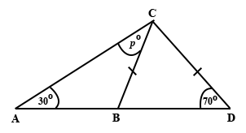
A.
110
B.
90
C.
70
D.
50
E.
40

17.

Make a subject of the relation P = 2(a + b)
A.
a =
P - 2b
2
B.
a =
P + 2b
2
C.
a =
2b - P
2
D.
a =
P - b
2
E.
a =
P - 2
b

18.

What is the value of x in the relation 5^{x} = 125?
A.
2
B.
3
C.
4
D.
5
E.
6

19.

Calculate the length of QR in triangle PQR
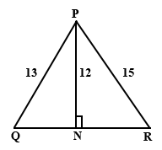
A.
11
B.
14
C.
16
D.
17
E.
25

20.

Five cards are numbered one to five. A card is picked at random. What is the probability that it has an even number?
A.
1
B.
4
5
C.
3
5
D.
2
5
E.
1
5

21.

If u =
(
2
1
)
and v =
(
-1
3
)
, find 3u + 2v.
A.
(
8
9
)
B.
(
4
-2
)
C.
(
4
0
)
D.
(
4
9
)
E.
(
-4
-9
)

22.

Arrange the following fractions in descending order
3
4
,
5
8
,
4
5
,
13
20
A.
4
5
,
3
4
,
13
20
,
5
8
B.
4
5
,
5
8
,
3
4
,
13
20
C.
5
8
,
4
5
,
3
4
,
13
20
D.
4
5
,
5
8
,
13
20
,
3
4
E.
13
20
,
5
8
,
4
5
,
3
4

23.

How many lines of symmetry has a square?
A.
0
B.
1
C.
2
D.
3
E.
4

24.

If (x, y) → (x, 2y), find the image of (2
1
2
, -
1
4
)
A.
(2
1
2
, -2)
B.
(2
1
2
, -
1
2
)
C.
(2, -2)
D.
(2, -
1
4
)
E.
(2, 2
1
2
)

25.

The ages in years of eight boys are: 14, 14.5, 15, 12, 11.5, 13, 10.5, 13.5.
What is their average age?
A.
14
B.
13
C.
12
D.
11
E.
10

26.

Convert 133_{five} to a base ten numeral.
A.
23
B.
25
C.
31
D.
40
E.
43

27.

Find the simple interest on ₵15,000.00 at rate of 20% per annum for 5 years.
A.
₵10,000.00
B.
₵15,000.00
C.
₵30,000.00
D.
₵50,000.00
E.
₵90,000.00

28.

List all members of the set {x: 2 < x < 8, x is an integer}
A.
{3, 4, 5}
B.
{2, 3, 4, 5, 6, 7, 8}
C.
{2, 2
1
2
, 3, 4, 5, 6, 7, 8}
D.
{3, 3
1
2
, 3, 4, 5, 6, 7, 8}
E.
{3, 4, 5, 6, 7}

29.

Simplify 348.94 - 188.34
A.
60.60
B.
60.68
C.
160.60
D.
200.60
E.
206.60

30.

Find the difference between the values of (2d)² and 2d² when d = 3
A.
16
B.
18
C.
24
D.
28
E.
54

31.

The heights of two boys are in the ratio 4 : 5. The shorter boy is 80 cm. What is the height of the taller boy?
A.
100 cm
B.
150 cm
C.
164 cm
D.
180 cm
E.
200 cm

32.

Factorize completely 5xy + 10ny
A.
5y(x + n)
B.
5y(x + 2n)
C.
5xy(1 + 2n)
D.
5(xy + 2ny)
E.
x(5x + 10n)

33.

If 13x – 12 = 5x + 60, find x
A.
–9
B.
–6
C.
4
D.
6
E.
9

34.

The length of a spring when a mass of n kg is hung on it is L = (74 + 15n) mm. What is the length of the spring when a mass of 1.20kg is hanged on it?
A.
75.20 mm
B.
89.00 mm
C.
92.00 mm
D.
97.00 mm
E.
104.00 mm

35.

In the figure below, triangle ABC is an enlargement of triangle ADE. If |AE| = 20 cm and |EC| = 10 cm. What is the scale factor of the enlargement?
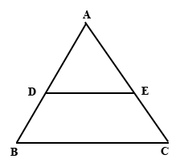
A.
1
2
B.
3
2
C.
2
D.
5
2
E.
3

36.

Which of the number lines below represents the inequality 2 < x ≤ 6?
A.
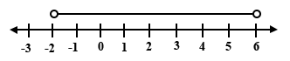
B.
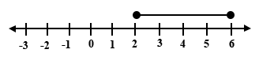
C.
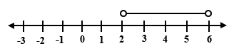
D.
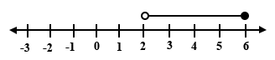
E.
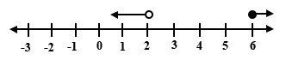

37.

A cylinder has a radius 6 cm and height 7 cm. Find its volume.
[Take π =
22
7
]
A.
132 cm³
B.
264 cm³
C.
294 cm³
D.
792 cm³
E.
924 cm³

38.

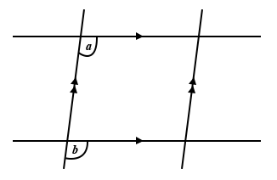
The angles a and b in the figure above are
A.
interior opposite
B.
corresponding
C.
vertically opposite
D.
acute
E.
alternate

39.

A man travelled a distance of 1.2 km in 30 minutes. What distance can he cover in 55 minutes travelling at the same speed?
A.
1.375 km
B.
2.02 km
C.
2.2 km
D.
12.02 km
E.
13.25 km

40.

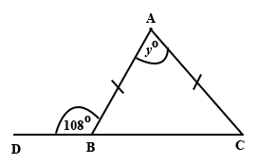
In the diagram above, ∆ABC is an isosceles triangle. ∠ABD is 108°. Find the value of y.
A.
72
B.
60
C.
48
D.
36
E.
24

